|  |  |
| --- | --- |
|  | **PES UNIVERSITY**  **DEPARTMENT OF COMPUTER SCIENCE AND ENGINEERING** |

**PROJECT TITLE**

**Seat Reservation System**

Use Case and Class Diagrams

|  |  |  |
| --- | --- | --- |
| Course Title: Object Oriented Analysis and Design | | |
| Course code: UE19CS353 | | |
| Semester : VI | Section: B | Team No: 6 |
| SRN: PES2UG19CS108 | Name: Dev Darshan J | |
| SRN: PES2UG19CS088 | Name: BHARGAV NARAYANAN P | |
| SRN: PES2UG19CS130 | Name: GOURAV ARAVINDA | |

Use Case Diagram

We have 2 main actors that will be present. The user and the database administrator. The user is the person who will be booking the trains based on the routes and trains shown. The administrator is the person who will be adding routes, trains and stations. We have created the diagram considering user authentication and the features that are needed to reserve a seat on a train.

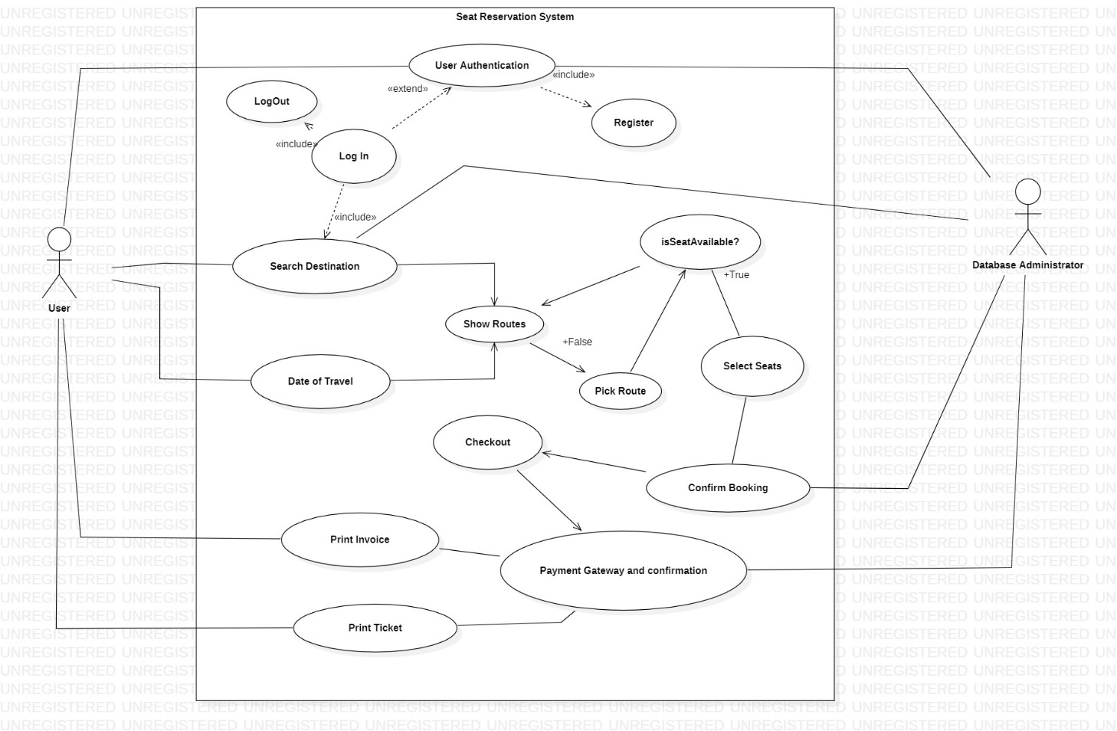

Class Diagram

We have considered 9 classes in total. We will be implementing classes for the following features

1)Stations

2)Destinations

3)Trains

4)Signup

5)Logout

6)Booking

7)User

8)Database Model

9)Database

